Figure 4. Proteins associated with Active GCA patient’s Physician Global Assessment and C-reactive protein levels.

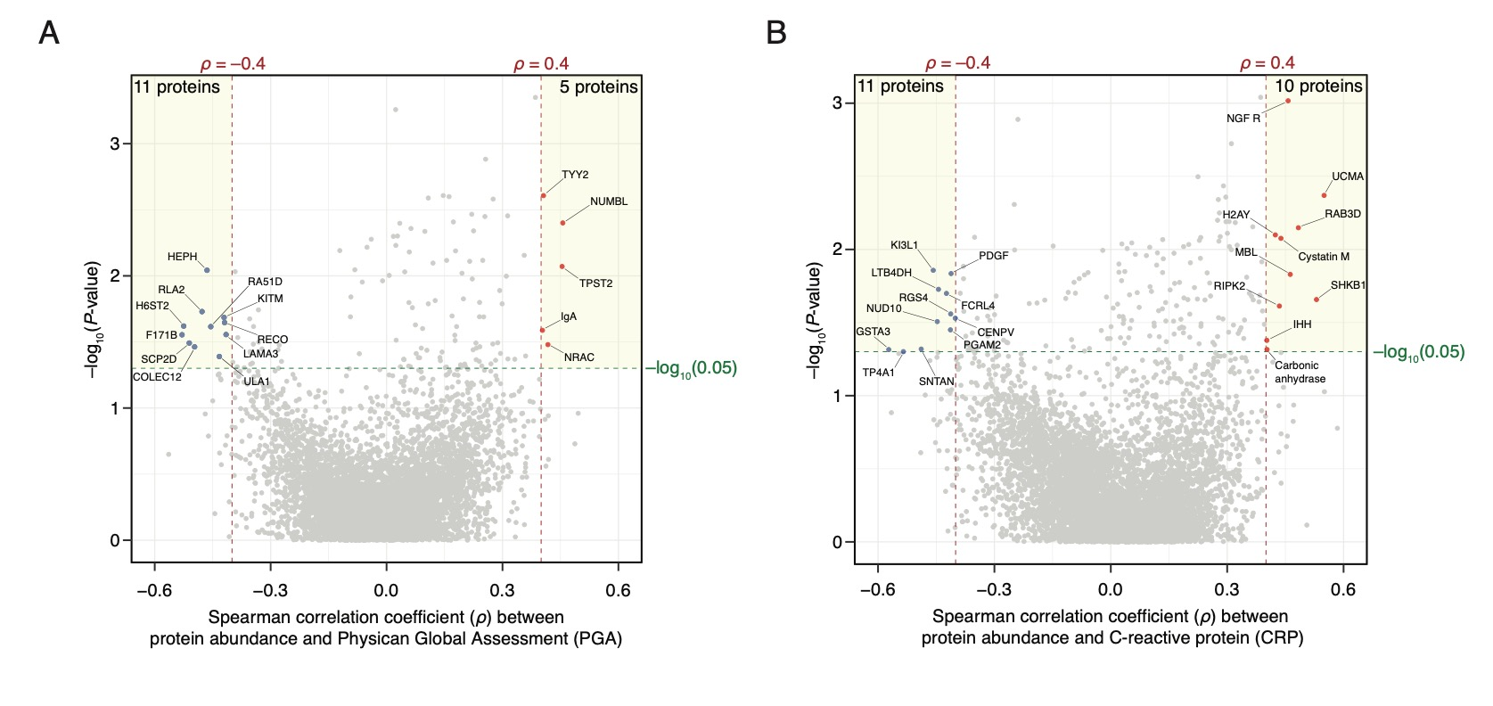

Linear modeling was done between Active GCA patients' (*n* = 30) protein abundances and PGA while accounting for the following confounders: age, sex, smoking status, prednisone use, methotrexate use, and aspirin use. A nominal *P*-value < 0.01 was used to determine significance. In addition, linear models were also built between Active GCA patients’ protein abundances and CRP levels when accounting for confounders.

(A) 16 proteins were found to be associated with PGA levels in Active GCA patients, with eleven proteins having negative associations and five proteins having positive associations.

(B) 21 proteins were found to be associated with CRP levels in Active GCA patients, with eleven having negative associations and 10 having positive associations.